Computer Vision Workshop – Final Project

Visual PONG

- User Manual -

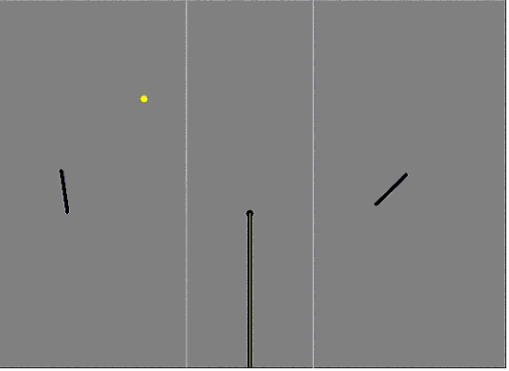

By

Table of Contents:
Introduction 3
Rules 3
Movement 3
The Camera 4
Menus 6
Settings 6
Single Game 7
Network Game 8
Requirements 9
Optional Enhancement 9

Introduction

The Game is a two-dimensional, webcam-using pong game. The movement of the player on the screen is inputted not through the conventional input devices such as the mouse, keyboard or joystick but rather through the webcam, which detects the spatial movement of the player’s paddle, and moves the “virtual” paddle accordingly.
It can be played as a single player playing against a computerized opponent, or against another player through the network.

Rules
The Main purpose of the game is to reach 10 points in order to win.
When a player scores a point, he will serve the next ball, which means the ball will fall from the ceiling to the player’s area, and he will be able to strike it first.

In the default mode the player will receive a point either if the ball touches his opponent’s back wall, or the ball touches his opponent’s floor more than once. If a Player Fails to pass the ball over the net his opponent will receive a point.

Each player will stand within some distance of the camera and will hold a real racket (which color and shape might be constant). He will move the racket in front of the camera and the paddle will imitate the movement of the racket (which means that the position and angle of the peddle will be calculated according to the position and angle of the racket).
There are two options in calculating the movement of the paddle
- According to the absolute position of the racket in front of the camera. If the Racket is in (x,y) the paddle will be in (fx(x),fy(y))
- According to the difference of the last move of the racket. (if the racket moves in (dx,dy) the paddle will move in (fx(dx), fy(dy)).
fx,fy – Are linear function that convert from the real dimensions of the camera and the dimensions off the game screen.

Movement

Each player controls one paddle, the paddle can move in two dimensions (Vertical, Horizontal) and it can also rotate around its axis.

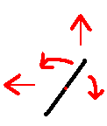

Each player moves its paddle with the purpose of hitting the ball and moving it over the net to the second player’s area. The Ball Bounces of the paddle according to the angle and speed of the paddle in the time of the hit, and it cannot move faster than a certain maximum speed.

The Paddles movement is restricted to an area distanced from the net and from the back wall.

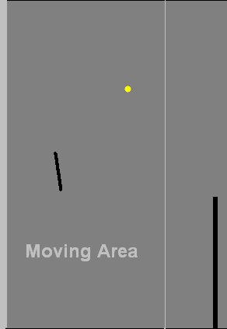

The ball will move according to the speed and angle given to it by the paddle. The speed will be mirrored from the ceiling and the floor in case the ball hits it.
In the future the ball might also have gravity and air friction.

The Camera
The camera will be in front of the player. The Player will be able to choose on which side of the board he wishes to play. The paddle will move to the same direction to which the racket is moving.

Before the game the camera will need set up, in which it will need the player to position his racket in a circle in the center of the screen. Then after positioning the racket there the application will show the player where the application thinks the racket is. During the setup the application will remember the color of the racket and its relative size to use later in the game.

The racket must be a rectangle with a special color on its side.

Example:
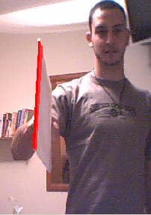

The Camera will detect two vertices of the racket and will make all is calculation according to those vertices. The Speed will be calculated according to difference of position in each iteration of the application.
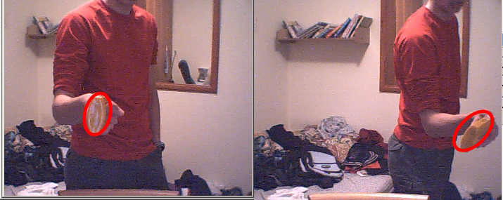

Menus
When the player starts the game a Main Menu will be shown.
The menu looks like this:

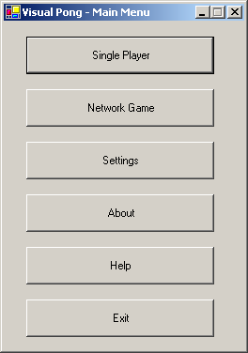

Settings
Clicking the "Settings" button will show this menu:
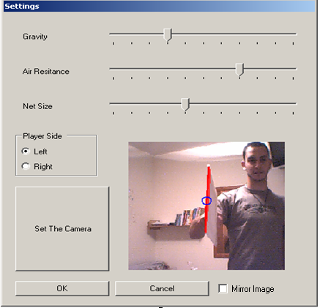

In the setting screen the player will be able to specify:
- The position of the camera (Left, Right)
- The Gravity and Air resistance factor.
- The size of the net.
- There he will also be able to set up the camera, and know whether it detects his racket properly. To set the camera the player will have to place his racket so it is centered in the blue circle. After pressing Set the picture will show what the application identifies as the racket.

Single Game
Selecting the "Single Game" button the Game board will be shown and the game will commence.
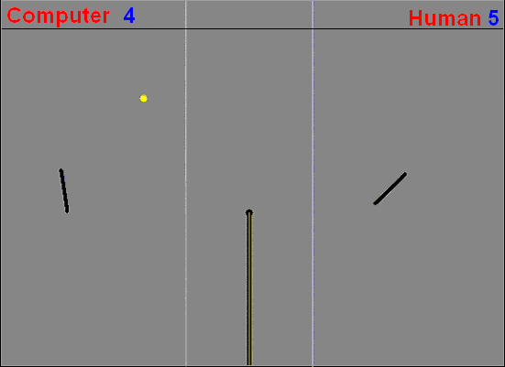

Network Game
Clicking the "Network Game" button will show this window:

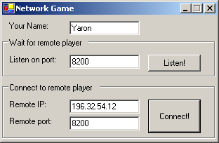

In host mode he will be waiting for a player to join him therefore he will need to select a port in which to listen.
In client mode he will need to specify the IP and port to which he wants to connect. In this mode he will be passive and the parameters of the host will be taken in consideration (Gravity, Air Friction, Net Size)

After the establishing of a connection with the second player the Game Board will be shown:

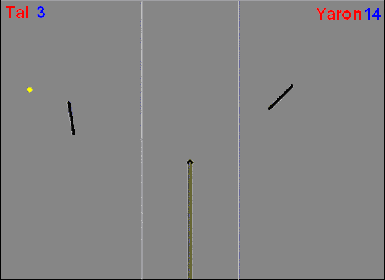

Clicking the "Help" button he will see this document.
Clicking the "About" button he will see the smiling faces of the developers.

Requirements
In order to use this software you need:
- Intel compatible CPU, preferably 1 GHZ or faster.
- At least 128 MB of RAM.
- Operating system: Windows 2000 / XP / 2003 or newer.
- Installed Webcam, including all relevant hardware and software drivers.
- Microsoft .NET framework.
- A square-profile racket, painted at the opposite edge of the handle in a distinct bright color.
- To play network game, you need a fast (10/100 Mbps) Ethernet controller installed on the system.

Optional Enhancement

- Improving the algorithm so that the racket can be any size, and any color.
- Making the Game Board More User Friendly (adding Pause Button, and private Chat)

- All the pictures are examples and might not appear the same in real version!

(C) All rights reserved – The visual pong team.

