Incremental Maintenance for Materialized Views over Semistructured Data
Written by: Serge Abiteboul, Jason McHugh, Michael Rys, Vasilis Vassalos, Janet L. Wiener
In this article the writers compared their new incremental maintenance algorithm over views with recomputing the view.
Introduction: Database views increase the flexibility of a database system. These views are adapted to a specific user or application. Views are materialized in order to speed up querying when the time is critical. In order to use views, we must maintained the view contents in order to preserve it consistency with the database. There are to ways to maintain the views: The first way is to recompute the view contents from the database, which means every time to create the view again. The second way is to compute the incremental updates to the view, based on the updates to the database. To perform this algorithm, we will use the new algorithm that this article suggested.
The new algorithm that is suggested is “Incremental Maintenance”, this algorithm is good for nearly all types of updates. Using this algorithm on the view is more efficient then recomputing the database.
The maintenance algorithm is based on the Object Exchange Model (OEM) and on the Lorel Query Language. In OEM the database is a directed graph with labels. Each vertex represents an object, each object has a unique name which is called oid.
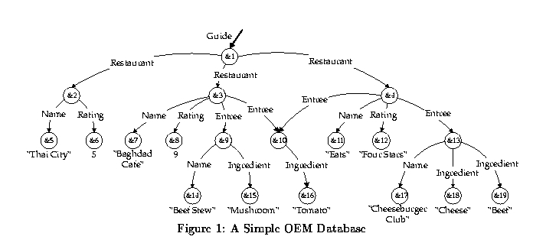
Atomic objects can be either integer, real, string, gif, java or audio. More over, Complex objects are pairs of labels and sub objects for example, {<entree,&10>,<name,&11>,<Rating,&12>,<entree,&13>} (see figure1)
Atomic
objects
vertex
Complex object

The Lorel query language is a query language. In this article they extended the lorel query language. The query language includes Select…from…where – specify the essential objects that are brought to the view. With – specify the paths from the essential objects to the sub objects. By this we receive a graph structured that hold all the data. This language provides a powerful path expressions for traversing the data and rules.
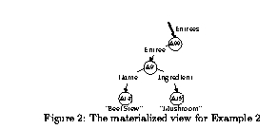
The view specification statements identify objects within a graph, import arbitrary sub graphs and add or remove objects appearing in the view.
Define view FavoriteEntrees as Entrees =
Select e
From Guide.Restaurant r, r.Entree e
Where exists x in r.Name = “Baghdad Cafe”
And exists y in e.Ingredient = “Mushroom”
With e.Name n, e.Ingredient I;
Adjunct objects
Primary objects – objects that are bounded to e.
Adjunct objects – objects discovered by the with clause.
Primary Objects

Update operations on the views:
- Insertion and deletion of the edge (<Ins,o1,L,o2> ,<Del,o1,L,o2>)
- Change a value of an atomic object (<chg,o1,OldVal,NewVal>)
The Incremental maintenance algorithm
The input: 1. View specification statements
2. Update U
3. New database DB’
4. View instance V
The algorithm:
- Check for relevance of update U to the view instance V defined by the view specification S. Generate a set of relevant variables R (we use it to check in a quick way if the update of the database affects the view). If R is empty, stop.
- Generate maintenance statements and create Add_{prim} and Del_{prim} using U,S and R.
- Generate maintenance statements and create Add_{adj} and Del_{adj} using U,S, R and Add_{prim} or Del_{prim}.
- Install Add_{prim} , Del_{prim,} Add_{adj} and Del_{adj} in V. (The order is first the delete and after is the add , this is to avoid duplicates of objects).

Calculating the cost on creating a view or by the new algorithm:
Fanout(x,L) – the estimated average number of children with the label l that are descendants of some objects that are bounded to x.
|x| - the estimated number of objects in the set x.
Cost(x,L,y) – the estimated cost.
Cost(x,L,y) = |x| * Fanout(x,L)
Total coast: Cost(total) = ∑ Cost(x,L,y)
^{(x,L,y)ε P}
The researcher contacted few experiments to compare the cost of recomputing the view to the new algorithm they suggested. According to their experiments, recomputing the whole view is more expensive than the new algorithm in the following checks: 1)changing an atomic value, inserting a new edge and deleting an edge. 2) Changing the size of the database. 3) The number of occurrence of a label (in the new algorithm it was cheaper but still each occurrence of a label required maintenance commands). 4) The length of the from clause.
Conclusions:
- The new algorithm is better than recomputing the whole view even for large numbers of insert and delete edge updates.
- Scales well with increasing the database
- The algorithm is still expensive when changing a single atomic value (it can be expensive as full recomputing).
My opinion:
I think they should continue to research and try to find a way to reduce the cost of the new algorithm even when changing an atomic value. Moreover, they should try to find a way to reduce the cost even when there is a number of occurrences of the same label. I think that in a way they can try to find a way to remember the path that would not require more maintenance commands.

